[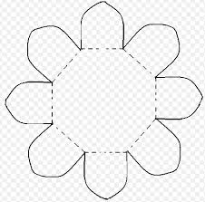](https://www.google.nl/url?sa=i&url=https%3A%2F%2Fwww.papiermachtschule.at%2Ffileadmin%2Fuser_upload%2FPapierbox%2FBox_Saugkraft%2FZauberblume_Zuendholzstern_layout.pdf&psig=AOvVaw34_2cp5suCC_-Z4KFAvx6p&ust=1585434353917000&source=images&cd=vfe&ved=0CAIQjRxqFwoTCICs2K3Zu-gCFQAAAAAdAAAAABAE)